

**USA Presidential**

**Candidates**

VIKESH MANIKANTA KARTHIK VAMSHI

Dr PRAVEEN RAO

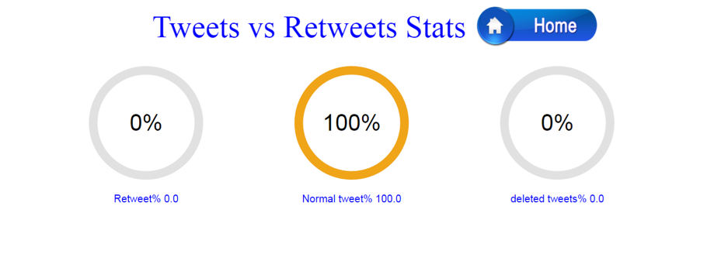 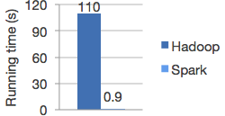

**SELECT COUNT(*) AS** c **FROM** tweetTable

**WHERE** text **LIKE** '%realDonaldTrump%'**;**

Query 1: Tweet Count On Presidential Candidates

**SELECT COUNT(*) AS** c **FROM** tweetTable **WHERE** text **LIKE** '%abundant%' **;**

Architecture

**SELECT** user.name, max(user.followers_count) **AS** c **FROM** tweetTable **GROUP BY** user.name **ORDER BY** c;

**SELECT** created_at, **COUNT(*) AS** c **FROM** tweetTable **Group By** created_at **ORDER BY** c;

**SELECT** user.name,max(user.statuses_count) **AS** c **FROM** tweetTable **GROUP BY** user.name **ORDER BY** c;

Query 6: Top 8 Most Tweeting Users

Query 5: Positive and Negative tweets

SELECT user.location,

COUNT(*) AS c

FROM tweetTable

Group By user.location

ORDER BY c;

Query 4: Top Locations with highest tweets

SELECT user.screen_name, max(user.friends_count) AS c FROM tweetTable WHERE user.friends_count>'150000' group by user.screen_name order by c

Query 3: Users with friends greater than 150000

**SELECT COUNT(*) AS** c **FROM** tweetTable **WHERE** retweeted='true' **or** retweet_count**>'0'**

Query 8: Top 8 Users with Highest Followers

Query 9: Tweet vs Retweet Status

Query 7: Top 8Most Tweeting Timestamps

Query 2: Tweets from Different Type of Devices

**SELECT COUNT(*) AS** c **FROM** tweetable

**WHERE** source **LIKE** '%Android%'**;**

Web Application

Apache Spark is a fast and general engine for large-scale data processing. Run programs up to 100x faster than Hadoop MapReduce in memory, or 10x faster on disk. Write applications quickly in Java, Scala, Python, R.